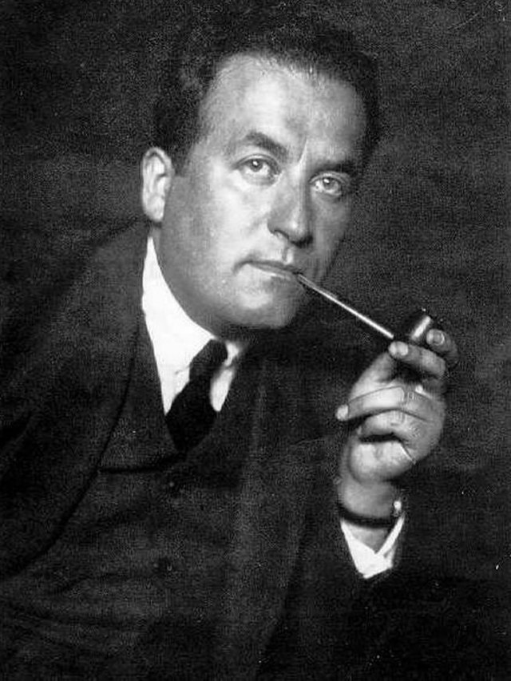

http://www.wikiwand.com/en/List_of_Asian_Nobel_laureates